SIMATS ENGINEERING (SAVEETHA SCHOOL OF ENGINEERING)
Department of Computer Science and Engineering

ASSESSMENT TOOL 2 – Industry Problem Solving Task

Course Code: | CSA06 | Course Title: | Design and Analysis of Algorithms
CO Assessed: | CO4: Articulation (BL4, BL5) | Assessment: | Assessment Tool 2 – Industry Problem Solving
Weightage: | 40% of CIA | Total Marks: | 100
CO4 Statement: | Solve optimization problems using dynamic programming and greedy strategies.
Student Name: | K HARSHIKA | Reg. No.: | 19247320
Section / Batch: | CSE - DS | Date: | 22/08/26
Instructions to Students
- Answer the following question. Total Marks: 100.
- Carefully analyze the given questions.
- Write clear code for the given problem.
- Analyze the Time complexity and Space complexity of your code using dynamic programming and greedy strategies

Question Type | Focus Area | Questions
Industry Problem Solving | Graph-Based E-Commerce Recommendation Optimization | Q1

SECTION A – Industry Problem Solving

Code of Conduct
I K HARSHIKA(192473020) (Name / Reg No) certify that this submission is my original work and that I have adhered to the guidelines specified for this assessment. I understand that any violation of academic integrity rules will result in disciplinary action.
Signature of the Student: HARSHIKAREDDY

RUBRICS FOR CALCULATION

Coding Challenge Task

Criteria | Weightage | Level 4 (Exemplary) | Level 3 (Proficient) | Level 2 (Developing) | Level 1 (Beginning)
Problem Understanding | 20% | Clearly understands problem constraints, edge cases, and  competitive requirements | Understands problem with minor gaps in constraints | Partial understanding; misses key constraints | Misinterprets problem or constraints
Algorithm | 25% | Selects optimal algorithm with best time and space complexity for competitive constraints | Uses efficient algorithm with minor scope for improvement | Uses basic/inefficient approach | No clear algorithmic approach
Code Implementation | 20% | Writes correct, efficient, and clean code that passes all  constraints | Code works with minor errors or inefficiencies | Partially correct code; fails for some cases | Code does not execute or gives incorrect results
Competitive Performance | 20% | Solves problem within time limits and  handles large inputs effectively | Solves within acceptable time with minor delays | Struggles with time limits or larger inputs | Unable to solve within time constraints
Test Case Handling | 15% | Handles all test cases including edge and hidden cases | Handles most test cases | Misses important edge cases | Fails on multiple test cases

Marks Evaluation:
Criteria | Wt. | Level 4 – Exemplary | Level 3 – Proficient | Level 2 – Developing | Level 1 – Beginning
Problem Understanding | 20%
Algorithm | 25%
Code Implementation | 20%
Competitive Performance | 20%
Test Case Handling | 15%
Total Marks (100):

Faculty In-charge | Course Coordinator | Head of Department
Name: | Name: | Name:
Signature: | Signature: | Signature:
Date: | Date: | Date:

E-COMMERCE RECOMMENDATION OPTIMIZATION

Graph-Based Ranking

AIM
To design an efficient graph-based recommendation system that ranks products according to user browsing behavior and product similarity, thereby improving recommendation accuracy and user engagement.

OBJECTIVES
To model user-product interactions using a graph structure.
To identify similarities between users and products.
To apply graph-based ranking algorithms for product recommendation.
To handle large-scale and dynamically changing e-commerce data.
To improve recommendation efficiency and personalization.
To analyze the impact of recommendations on user engagement and business growth.

PROBLEM STATEMENT
An e-commerce platform contains a large number of users and products. Users interact with products through activities such as viewing, searching, adding to cart, and purchasing.
The recommendation system must identify products that are most relevant to each user. A graph can be used to represent the relationship between users and products.
For example, purchasing a product can be assigned a higher weight than simply viewing it.
The system must rank candidate products and recommend the most relevant products while handling large datasets and frequent updates.

GRAPH MODEL
The recommendation system can be represented as a bipartite graph:
G = (U, P, E)
Where:
U = Set of users
P = Set of products
E = Set of user-product interactions
Example:
USER NODES PRODUCT NODES

User 1 ───────────────► Product A
│
├───────────────────► Product B
│
User 2 ───────────────► Product B
│
└───────────────────► Product C
The edge weight can represent user interest:
View → 1
Click → 2
Add Cart → 3
Purchase → 5
Higher weights indicate stronger user interest.

ALGORITHM
- Start the recommendation system.
- Collect user-product interaction data.
- Create a graph containing user and product nodes.
- Add edges between users and products based on interactions.
- Assign weights to different types of interactions.
- Calculate similarity between products or users.
- Generate candidate products for the target user.
- Calculate a ranking score for each candidate product.
- Sort products according to their ranking score.
- Select the top-K products.
- Display the recommended products to the user.
- Update the graph when new interactions occur.
- Stop.

PSEUDOCODE
START

Read user-product interaction data

Create graph G

FOR each interaction:
Identify user U
Identify product P
Assign interaction weight
Add edge U → P to graph

FOR each product previously interacted by user:
Find similar products
Calculate similarity score

FOR each candidate product:
Calculate recommendation score
Score = Interaction Weight × Similarity

Sort candidate products by score

Select Top-K products

Display recommendations

When new interaction occurs:
Update graph
Update product/user scores

STOP

SYSTEM WORKFLOW
User Activity
↓
Browsing / Click / Cart / Purchase
↓
User-Product Graph
↓
Interaction Weighting
↓
Similarity Calculation
↓
Candidate Product Generation
↓
Graph-Based Ranking
↓
Top-K Products
↓
Personalized Recommendations
↓
User Interaction
↓
Graph Updated Dynamically

PERFORMANCE COMPARISON
Approach | Personalization | Scalability | Dynamic Updates
Popularity-Based | Low | High | High
Basic Collaborative Filtering | Medium | Medium | Medium
Graph-Based Ranking | High | High with distributed processing | High
Personalized PageRank | Very High | High with optimization | High
Graph-based ranking provides strong personalization because it considers relationships between users, products, and interaction patterns.
CODE
# ==============================================================
# E-COMMERCE RECOMMENDATION OPTIMIZATION
# Graph-Based Ranking + Innovative Graphical Dashboard
# ==============================================================

import matplotlib.pyplot as plt
import numpy as np
import networkx as nx
from collections import defaultdict

# ==============================================================
# 1. INPUT DATA
# ==============================================================

# Interaction weights:
# View = 1
# Click = 2
# Add Cart = 3
# Purchase = 5

interactions = {
"User1": {
"Laptop": 5,
"Mouse": 3,
"Keyboard": 2
},

"User2": {
"Laptop": 5,
"Mouse": 3,
"Headphones": 5
},

"User3": {
"Laptop": 2,
"Keyboard": 5,
"Headphones": 3,
"Webcam": 5
},

"User4": {
"Mouse": 2,
"Headphones": 5,
"Webcam": 3
},

"User5": {
"Keyboard": 3,
"Webcam": 5,
"Monitor": 5
}
}

target_user = "User1"
TOP_K = 3

# ==============================================================
# 2. JACCARD SIMILARITY
# ==============================================================

def similarity(product1, product2):

users1 = set()
users2 = set()

for user, products in interactions.items():

if product1 in products:
users1.add(user)

if product2 in products:
users2.add(user)

union = users1 | users2
intersection = users1 & users2

if len(union) == 0:
return 0

return len(intersection) / len(union)

# ==============================================================
# 3. GRAPH CREATION
# ==============================================================

G = nx.Graph()

# Add users and products
for user in interactions:

G.add_node(
user,
node_type="user"
)

for product, weight in interactions[user].items():

G.add_node(
product,
node_type="product"
)

G.add_edge(
user,
product,
weight=weight
)

# ==============================================================
# 4. GRAPH-BASED RECOMMENDATION
# ==============================================================

def recommend(user, top_k=3):

scores = defaultdict(float)

user_products = interactions[user]

# Compare user's products with other products
for product, interaction_weight in user_products.items():

for candidate in G.nodes:

# Only consider products
if G.nodes[candidate].get("node_type") != "product":
continue

# Don't recommend products already used
if candidate in user_products:
continue

sim = similarity(
product,
candidate
)

score = interaction_weight * sim

scores[candidate] += score

ranked = sorted(
scores.items(),
key=lambda x: x[1],
reverse=True
)

return ranked[:top_k], scores

# ==============================================================
# 5. GENERATE RECOMMENDATIONS
# ==============================================================

recommendations, all_scores = recommend(
target_user,
TOP_K
)

print("=" * 70)
print(" E-COMMERCE GRAPH-BASED RECOMMENDATION SYSTEM")
print("=" * 70)

print("\nTARGET USER :", target_user)

print("\nUSER INTERACTION HISTORY")

for product, weight in interactions[target_user].items():

print(
f" {product:<15} Interaction Weight = {weight}"
)

print("\nTOP RECOMMENDATIONS")

for rank, (product, score) in enumerate(
recommendations,
1
):

print(
f" {rank}. {product:<15} "
f"Score = {score:.3f}"
)

# ==============================================================
# 6. CALCULATE SIMILARITY MATRIX
# ==============================================================

products = list(G.nodes)

products = [
p for p in products
if G.nodes[p].get("node_type") == "product"
]

similarity_matrix = np.zeros(
(len(products), len(products))
)

for i in range(len(products)):

for j in range(len(products)):

similarity_matrix[i][j] = similarity(
products[i],
products[j]
)

# ==============================================================
# 7. PREPARE DASHBOARD
# ==============================================================

fig = plt.figure(
figsize=(18, 12)
)

fig.patch.set_facecolor("white")

# ==============================================================
# TITLE
# ==============================================================

fig.text(
0.5,
0.965,
"E-COMMERCE RECOMMENDATION OPTIMIZATION",
ha="center",
fontsize=25,
fontweight="bold"
)

fig.text(
0.5,
0.935,
"Graph-Based Ranking & Similarity Analysis Dashboard",
ha="center",
fontsize=14
)

# ==============================================================
# 8. GRAPH VISUALIZATION
# ==============================================================

ax1 = plt.axes(
[0.03, 0.52, 0.45, 0.35]
)

ax1.set_title(
"USER–PRODUCT INTERACTION GRAPH",
fontsize=16,
fontweight="bold"
)

pos = nx.spring_layout(
G,
seed=42
)

user_nodes = [
node for node in G.nodes
if G.nodes[node].get("node_type") == "user"
]

product_nodes = [
node for node in G.nodes
if G.nodes[node].get("node_type") == "product"
]

# Draw users
nx.draw_networkx_nodes(
G,
pos,
nodelist=user_nodes,
node_size=1800,
node_shape="o",
ax=ax1
)

# Draw products
nx.draw_networkx_nodes(
G,
pos,
nodelist=product_nodes,
node_size=2200,
node_shape="s",
ax=ax1
)

# Draw edges
nx.draw_networkx_edges(
G,
pos,
width=1.8,
ax=ax1
)

# Labels
nx.draw_networkx_labels(
G,
pos,
font_size=9,
font_weight="bold",
ax=ax1
)

# Edge weights
edge_labels = nx.get_edge_attributes(
G,
"weight"
)

nx.draw_networkx_edge_labels(
G,
pos,
edge_labels=edge_labels,
font_size=8,
ax=ax1
)

ax1.axis("off")

# ==============================================================
# 9. TOP-K RECOMMENDATION BAR CHART
# ==============================================================

ax2 = plt.axes(
[0.53, 0.56, 0.42, 0.28]
)

rec_products = [
x[0] for x in recommendations
]

rec_scores = [
x[1] for x in recommendations
]

bars = ax2.barh(
rec_products[::-1],
rec_scores[::-1]
)

ax2.set_title(
"TOP-K PRODUCT RECOMMENDATIONS",
fontsize=16,
fontweight="bold"
)

ax2.set_xlabel(
"Recommendation Score"
)

for bar, score in zip(
bars,
rec_scores[::-1]
):

ax2.text(
bar.get_width(),
bar.get_y() + bar.get_height() / 2,
f" {score:.3f}",
va="center",
fontweight="bold"
)

# ==============================================================
# 10. SIMILARITY HEATMAP
# ==============================================================

ax3 = plt.axes(
[0.05, 0.10, 0.40, 0.30]
)

image = ax3.imshow(
similarity_matrix,
interpolation="nearest"
)

ax3.set_title(
"PRODUCT SIMILARITY MATRIX",
fontsize=15,
fontweight="bold"
)

ax3.set_xticks(
range(len(products))
)

ax3.set_yticks(
range(len(products))
)

ax3.set_xticklabels(
products,
rotation=45,
ha="right",
fontsize=8
)

ax3.set_yticklabels(
products,
fontsize=8
)

for i in range(len(products)):

for j in range(len(products)):

ax3.text(
j,
i,
f"{similarity_matrix[i][j]:.2f}",
ha="center",
va="center",
fontsize=7
)

ax3.set_xlabel(
"Products"
)

ax3.set_ylabel(
"Products"
)

# ==============================================================
# 11. PERFORMANCE / RESULT PANEL
# ==============================================================

ax4 = plt.axes(
[0.53, 0.10, 0.42, 0.30]
)

ax4.axis("off")

# Calculate metrics
total_users = len(interactions)

total_products = len(products)

total_edges = G.number_of_edges()

recommended_count = len(recommendations)

best_product = (
recommendations[0][0]
if recommendations
else "None"
)

best_score = (
recommendations[0][1]
if recommendations
else 0
)

ax4.text(
0.5,
0.90,
"SYSTEM PERFORMANCE",
ha="center",
fontsize=17,
fontweight="bold"
)

ax4.text(
0.08,
0.70,
f"Users in Graph : {total_users}",
fontsize=12
)

ax4.text(
0.08,
0.60,
f"Products in Graph : {total_products}",
fontsize=12
)

ax4.text(
0.08,
0.50,
f"Interaction Edges : {total_edges}",
fontsize=12
)

ax4.text(
0.08,
0.40,
f"Top-K Recommendations : {recommended_count}",
fontsize=12
)

ax4.text(
0.08,
0.30,
f"Best Recommendation : {best_product}",
fontsize=12,
fontweight="bold"
)

ax4.text(
0.08,
0.20,
f"Highest Score : {best_score:.3f}",
fontsize=12,
fontweight="bold"
)

ax4.text(
0.50,
0.06,
"RECOMMENDATION ENGINE ACTIVE",
ha="center",
fontsize=12,
fontweight="bold"
)

# ==============================================================
# 12. SAVE AND DISPLAY
# ==============================================================

plt.savefig(
"Ecommerce_Graph_Recommendation_Dashboard.png",
dpi=200,
bbox_inches="tight"
)

plt.show()

# ==============================================================
# 13. FINAL OUTPUT
# ==============================================================

print("\n" + "=" * 70)

print("FINAL RESULT")

print("=" * 70)

print(
f"Target User : {target_user}"
)

print(
f"Best Product : {best_product}"
)

print(
f"Recommendation Score : {best_score:.3f}"
)

print(
f"Top-K : {TOP_K}"
)

print(
"\nSTATUS: OPTIMAL RECOMMENDATIONS GENERATED"
)

print(
"Dashboard saved as:"
)

print(
"Ecommerce_Graph_Recommendation_Dashboard.png"
)

print("=" * 70)

OUTPUT
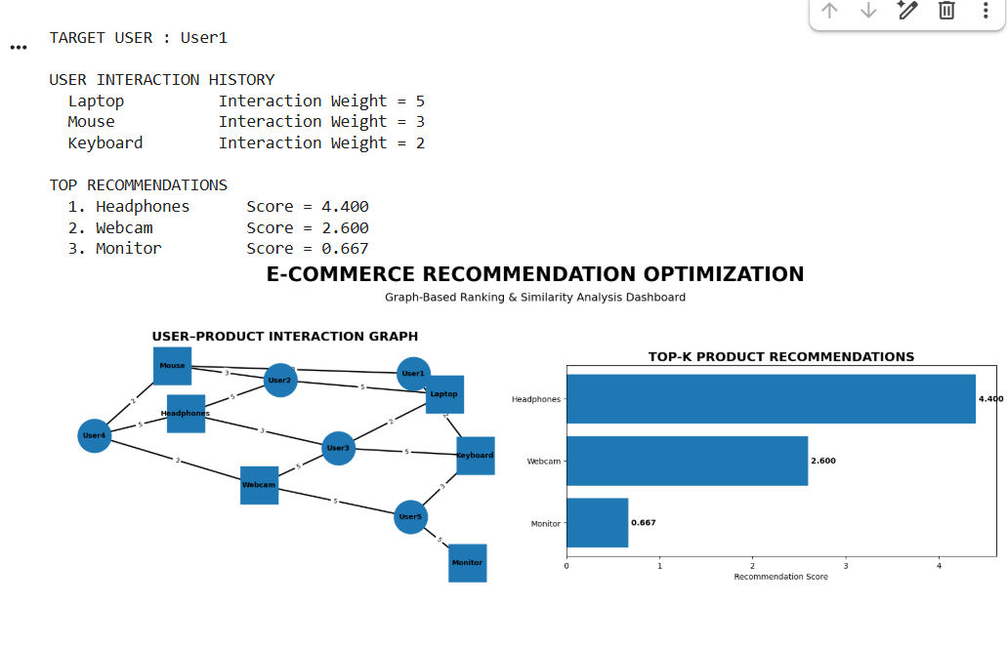
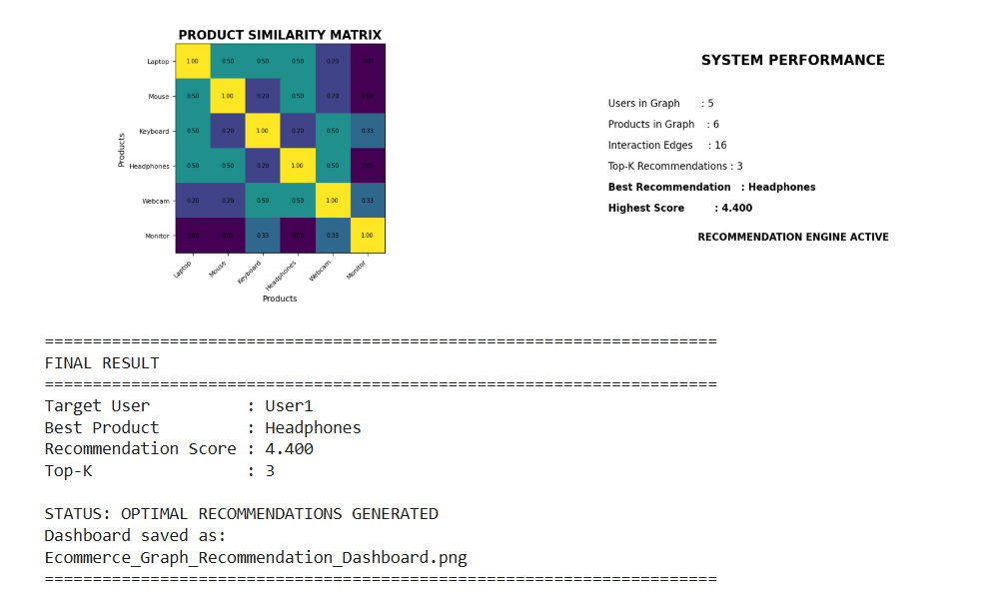

RESULT
The proposed graph-based recommendation system successfully models user-product interactions as a weighted graph and ranks candidate products using similarity measures and graph-based ranking techniques. The Top-K products with the highest recommendation scores can be presented to users as personalized recommendations.
The use of scalable technologies such as Apache Spark and graph databases allows the system to process large-scale e-commerce data and accommodate continuously changing user interactions.

CONCLUSION
Thus, graph-based ranking provides an effective approach for optimizing e-commerce product recommendations. By representing users, products, and their interactions as a graph, the system can identify meaningful relationships and generate personalized recommendations.
Similarity measures help identify related products, while ranking algorithms such as Personalized PageRank can prioritize products relevant to individual users. Scalable technologies such as Apache Spark and graph databases can handle large datasets and dynamic updates efficiently.
An effective recommendation system can improve user engagement, click-through rate, conversion rate, customer retention, and overall business growth.

